Explain the need of dimensionality reduction.
Dimensionality reduction is the process of reducing the number of input variables or features in a dataset while retaining as much meaningful information as possible.
It is needed for several important reasons:

Dimensionality Reduction Techniques
They are broadly divided into two categories:

1. Feature Selection
Selects the most relevant features without modifying them, removing redundancy and irrelevance.
- Filter Methods: Rank features by relevance to the target.
- Wrapper Methods: Use model performance to choose features.
- Embedded Methods: Perform selection during model training (e.g., LASSO, decision trees).

2. Feature Extraction
Transforms or combines original features to create fewer, informative ones.
- PCA: Converts correlated features into uncorrelated principal components while preserving variance.
- Factor Analysis: Groups correlated variables and retains key factors.
- ICA: Finds statistically independent components for specialized tasks like blind source separation.

1. Removes Irrelevant or Redundant Features
- Real-world datasets often contain many features that do not contribute to the prediction or analysis.

2. Reduces Computational Cost
- High-dimensional data requires more storage, memory, and processing power.
- Machine learning algorithms become slower as the number of features grows.

4. Helps in Data Visualization
- Human beings can visualize data only in 2D or 3D.
- By reducing data to 2 or 3 dimension

5. Improves Model Performance & Reduces Overfitting
- Too many features can cause models to memorize noise instead of learning true patterns.
✅ Dimensionality reduction removes noisy features, leading to better generalization and less overfitting
. Explain Minimum spanning tree based clustering with example.
A Minimum Spanning Tree is a subset of edges in a connected, undirected graph that:
- Connects all vertices together
- Has no cycles
- Minimizes the total edge weight
Algorithms like Kruskal’s and Prim’s are commonly used to construct MSTs efficiently2.

🧠 MST-Based Clustering: Concept
Instead of using distance thresholds or density (like DBSCAN), MST-based clustering:
- Builds an MST from the data points (treated as graph nodes).
- Removes the longest edges to break the tree into disconnected components.
- Each component becomes a cluster.
This approach is especially useful when clusters are not spherical or vary in size.

Explain following terms with respect to DBSCAN algorithm a. Core point b. Noise point c. Border point d. Directly density reachability e. Indirectly density reachability

Core Point
- A data point is a core point if it has at least MinPts (minimum number of points) within its ε (epsilon) radius.
- These points lie in dense regions and are the starting seeds for forming clusters.
- Example: If ε = 1.0 and MinPts = 4, any point with 4 or more neighbors within 1.0 distance is a core point.

b. Noise Point
- A noise point (or outlier) is a point that is not a core point and not reachable from any core point.
- It doesn’t belong to any cluster.
- These are typically isolated or lie in sparse regions.

c. Border Point
- A border point is not a core point itself (i.e., it has fewer than MinPts neighbors), but it lies within the ε radius of a core point.
- It’s part of a cluster but doesn’t contribute to expanding it.
- Think of it as a fringe member of a dense group.

d. Directly Density-Reachable
- A point q is directly density-reachable from point p if:
  - q is within ε distance of p, and
  - p is a core point.
- This is the basic building block for forming clusters.

e. Indirectly Density-Reachable
- A point q is indirectly density-reachable from point p if:
  - There exists a chain of points p1,p2,...,pnp_1, p_2, ..., p_n such that:
    - Each point is directly density-reachable from the previous one.
    - The chain starts at p and ends at q.
    - All intermediate points are core points, but q can be a border point.
- This allows DBSCAN to connect points across dense regions even if they’re not directly adjacent

Explain Density Based Clustering with the help of DBSCAN algorithm with example.
Density-based clustering groups data points that are closely packed together (high density areas), and separates them from points in low-density regions (noise or outliers). Unlike K-Means, it doesn’t assume clusters are spherical or require you to predefine the number of clusters.

Key Parameters:
- ε (epsilon): Radius to search for neighboring points.
- MinPts: Minimum number of points required to form a dense region (including the point itself).

DBSCAN Algorithm Steps
- Pick an unvisited point.
- Check ε-neighborhood: Count the number of points within ε.
  - If count ≥ MinPts → it’s a core point → start a new cluster.
  - Else mark it as noise (temporarily; may change later if found near a core).
- Expand cluster: Add all points in the neighborhood.
  - For each neighbor that is a core point, include its neighbors too.
- Repeat until all points are visited.
- Noise points remain unclustered
Explain the following splitting criteria w.r.t to decision tree. a. Entropy b. GINI Index
Entropy is a measure of impurity or randomness in the data.
It tells us how mixed the classes are in a node.
Gini Index measures the probability of misclassifying a randomly chosen element. It’s also a measure of impurity, but calculated differently.
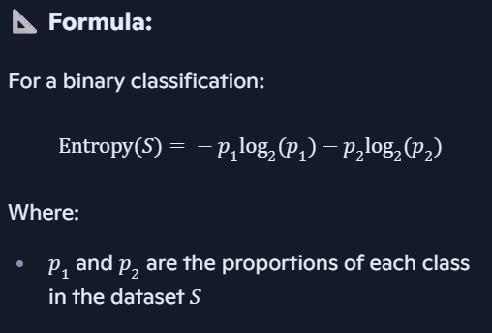
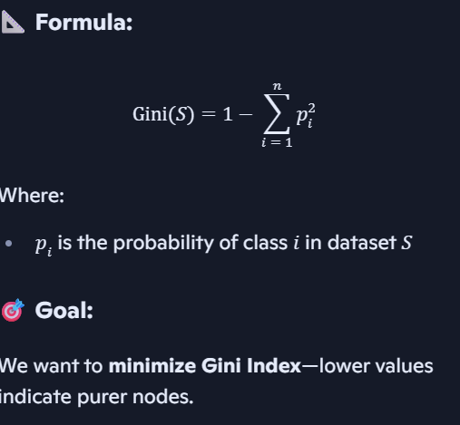
Discuss Random Forest in detail with example
Random Forest is an ensemble learning method that builds multiple decision trees and merges their results to improve accuracy and reduce overfitting. It’s like asking a group of experts (trees) and taking a majority vote (classification) or average (regression).
Here’s a step-by-step breakdown:
- Bootstrap Sampling:
  - Random subsets of the training data are created (with replacement).
  - Each subset is used to train a separate decision tree.
- Feature Randomness:
  - At each split in a tree, only a random subset of features is considered.
  - This ensures diversity among trees and reduces correlation.
- Tree Construction:
  - Each tree is grown to its full depth (or until a stopping criterion).
  - No pruning is done.
- Prediction Aggregation:
  - For classification: majority voting across trees.
  - For regression: average of all tree predictions.
Strong learners and weak learners

What Are Weak Learners?
A weak learner is a model that performs just slightly better than random guessing.
- In binary classification, this means accuracy is just above 50%.
- Weak learners are typically simple models with low complexity.
- They tend to underfit the data, capturing only basic patterns.

🔍 Examples:
- A decision stump (a decision tree with only one split)
- A logistic regression model with very few features
- A naive Bayes classifier on noisy data
Despite their simplicity, weak learners are valuable building blocks in ensemble methods.

💪 What Are Strong Learners?
A strong learner is a model that can achieve high accuracy and learn complex patterns in the data.
- It has low error rates and generalizes well.
- Strong learners are often complex models with high capacity.
- They can overfit if not properly regularized.

🔍 Examples:
- Random Forest
- Gradient Boosting Machines (GBM)
- Support Vector Machines (SVM)
- Deep Neural Networks

🔄 How They Work Together: Boosting
Boosting is a technique that combines multiple weak learners to create a strong learner.
- Each weak learner focuses on the errors of the previous one.
- Over time, the ensemble becomes highly accurate.
- Famous algorithms: AdaBoost, XGBoost, LightGBM

AdaBoost is an ensemble learning method that builds a strong classifier by combining multiple weak classifiers, typically decision stumps (trees with one split). It works sequentially, giving more focus to the data points that previous models got wrong.

🔄 How AdaBoost Works: Step-by-Step
- Initialize Weights
  - All training samples start with equal weight.
- Train a Weak Learner
  - A simple model (e.g., decision stump) is trained using the weighted data.
- Evaluate Errors
  - Misclassified samples get higher weights so the next learner focuses on them.
- Compute Learner’s Weight (α)
  - Based on error rate: better learners get more say in the final prediction.
- Repeat
  - Continue training new learners, each correcting the previous one.
- Final Prediction
  - Combine all learners using their weights to make a strong prediction.
Key points
- Sequential ensemble: Each learner corrects previous mistakes.
- Uses weighted samples to focus on hard cases.
- Combines weak learners into a strong, accurate model.
- Commonly uses decision stumps as weak learners.

Aspect | Bagging (Bootstrap Aggregating) | Boosting
Goal | Reduce variance and avoid overfitting | Reduce bias (and also variance) to improve accuracy
Training of Models | Models are trained independently and in parallel | Models are trained sequentially, each learning from previous errors
Sampling Method | Uses sampling with replacement (bootstrap samples) | Uses the entire dataset, but reweights samples to focus on hard cases
Model Type | Builds multiple strong learners (e.g., full decision trees) | Builds an ensemble of weak learners (e.g., shallow trees / stumps)
Error Handling | Averages predictions to reduce variance | Each new model tries to correct errors made by the previous models
Combination of Models | Uses averaging (regression) or majority vote (classification) | Uses weighted combination of models
Tendency to Overfit | Less prone to overfitting | Can overfit if too many iterations or weak regularization
Parallelization | Easy (since models are independent) | Harder (sequential dependency)
Popular Algorithms | Random Forest | AdaBoost, Gradient Boosting, XGBoost

